**3 GraphQLResolver Vs GraphQLQueryResolver**

* BankAccountResolver and gquery.graphqls are matched by means of interface GraphQLQueryResolver

* GraphQLQueryResolver is a marker interface

* Framework will pick all classes that implements GraphQLQueryResolver ,it then checks for matching signature of the method to the graphql defined query . method name: bankAccount should be matched

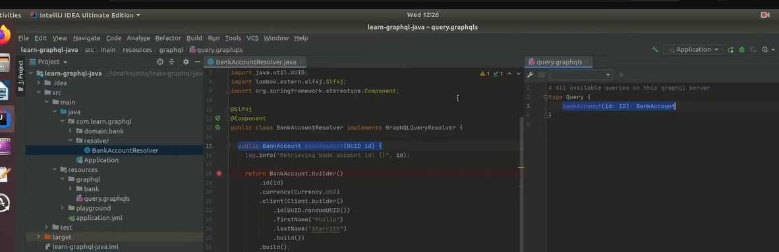

**. GraphQLResolver in picture:**

